**Power BI Solution Template Report Walkthrough**

The aim of this document is to walk through the Sales Management Solution Template.

**Sales Manager Persona**

As a Sales Manager, I manage anywhere between a few individual salespeople, to many sales teams with multiple levels of hierarchy. My sales teams use CRM to input information about the open opportunities they are working on. I also use an ERP system to track actual sales (i.e. all of the opportunities my sales team(s) have closed). My performance is measured against quotas that I receive from the Finance Department. These quotas are set against my salespeople and/or products.

As a Sales Manager I am interested in tracking my overall performance and progress, but I would also like to see how my sales teams or even individual sales people are performing. When measuring progress, it is important for me to see all of my relevant data (open revenue, closed revenue and quotas) together in one place. This allows me to answer key questions like:

* Which opportunities did I lose yesterday? Which of those was I expecting to win?
* How much actual sales have I closed this month? How does this compare to the same time period last year or the year before?
* How much pipeline coverage do I have for this quarter? How does this differ by sales team and product?
* How much variance to quota do I have by sales team?
* What does my win loss ratio look like for my worst performing product?

**Sales Management Report**

The next few pages go through a detailed walkthrough of each page of the Sales Management reports. They include a high level aim of the page, a description as well as screenshots.

**Daily View:**

**Aim:** As a Sales Manager, I want to view detailed information about important things that change on a daily basis.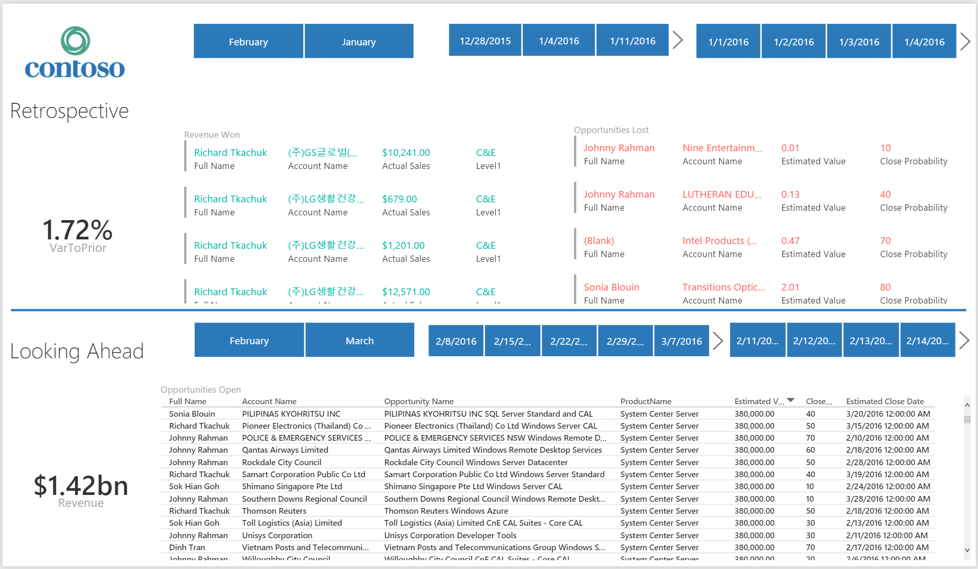

Figure 1: Daily View

**Description:** The ‘Daily View’ page is split into two key sections: ‘Retrospective’ and ‘Looking Ahead’.

The ‘Retrospective’ View is concerned about reporting on things that have already happened this quarter. There are two key tables to focus on – all of the revenue my team has brought in this quarter and all of the opportunities that have been lost this quarter. On the left hand side you can also see the ‘Variance to Prior Day’ metric. This gives me a quick indicator of how much my sales have increased since yesterday.

‘Looking Ahead’ on the other hand, is concerned with all of the opportunities that remain open this quarter. It gives me details on who owns a given opportunity, how much it’s worth and when should it close. A key metric given on the left hand side is how much revenue is in the pipeline.

An important aim of the ‘Daily View’ however, is to give a Sales Manager the finest level of granularity they may wish to view their data by. Whilst the default report page looks at things on a quarter level, a Sales Manager may be interested in seeing the opportunities that were lost this week or the opportunities that are expecting to close tomorrow. By using the time slicers present on the page, a Sales Manager can view their data at a month, week or day level. The slicers at the top of the page update the ‘Retrospective view (i.e. the past), whereas the slicers in the second half of the page update everything ‘Looking Ahead’.

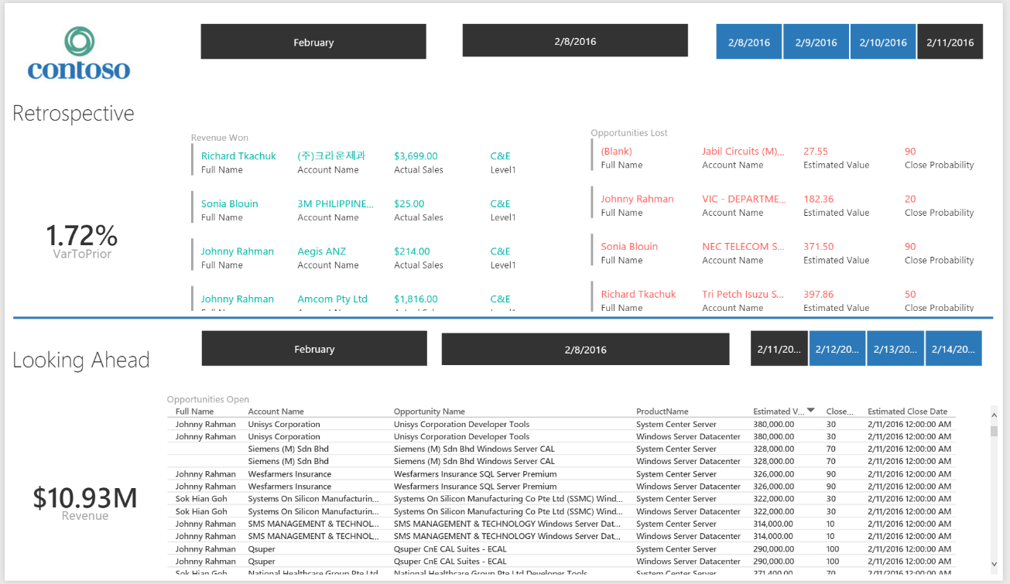

Figure 2: Daily View with time filters set to look only at today

**Sales Performance:**

**Aim:** As a Sales Manager, I want to use historical data to evaluate the current performance of my sales team(s)

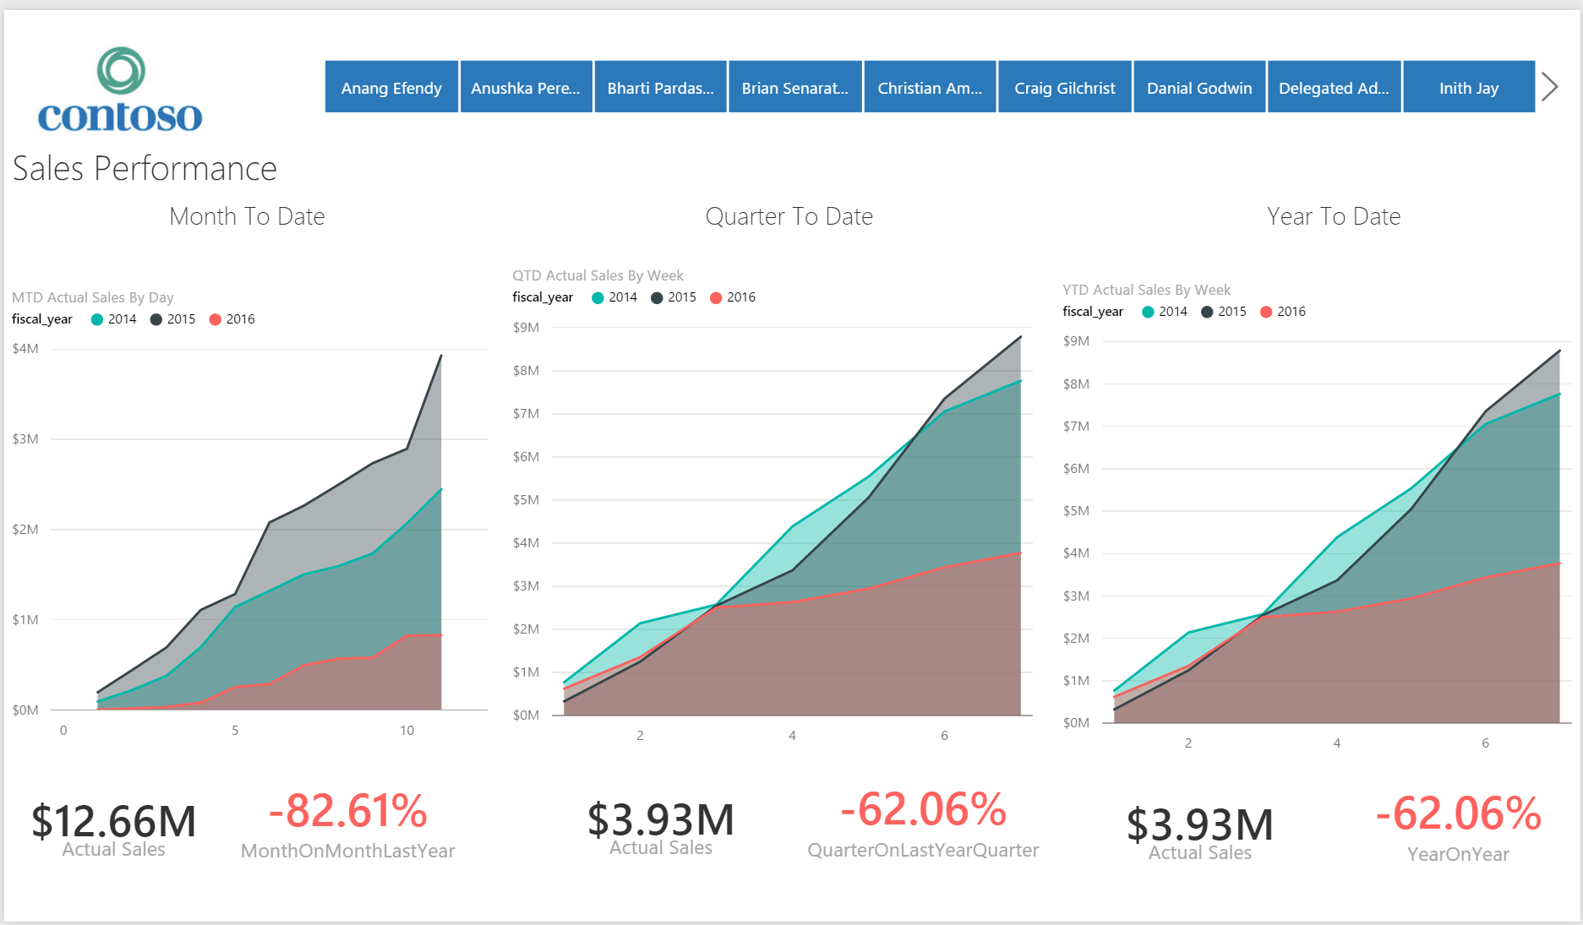

Figure 3: Sales Performance View

**Description:** The Sales Performance view helps Sales Managers answer questions about how their teams are performing compared to previous years. The right hand side of the page look at Year to Date sales (i.e. all sales that have occurred between today and the beginning of the year). It then contrasts these sales with sales for the **same time period** but in previous years. In the screenshot we can thus see sales for the first 7 weeks of the year compared to the first 7 weeks in 2015 and 214. We can then also view important high level metrics around how much revenue we have made this year as well as our growth compared to last year.

The middle graph shows the same information at a quarter view whereas the left hand graph looks at month to date sale. In our example above, month to date and year to date sales are the same. This is because we are still in the first quarter of the year. The month to date view on the other hand, shows a different picture. Here we are looking at the first 11 days of February (our current month) and comparing them to the first 11 days of February in 2015 and 2014.

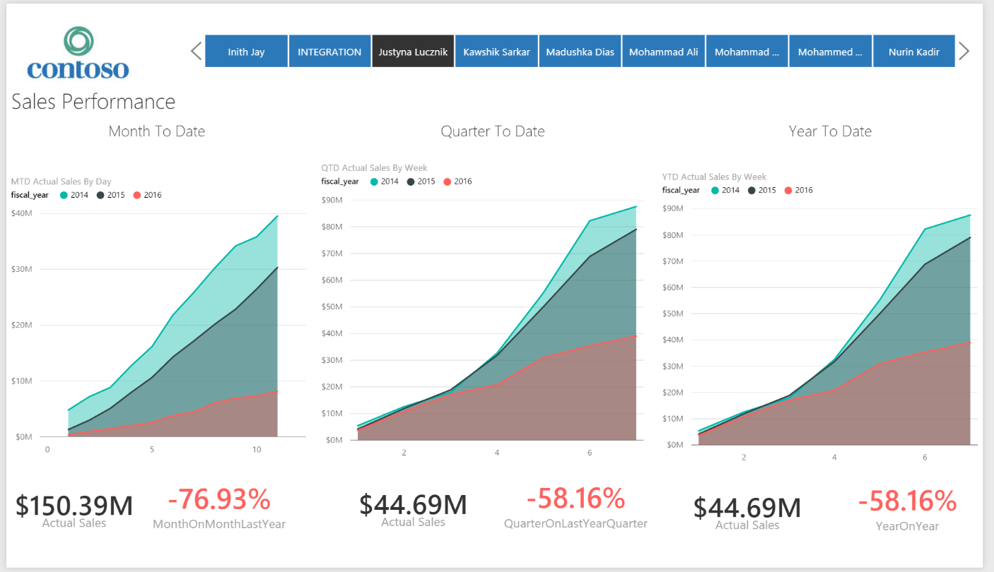Finally, the slicers at the top of the page include all of the Sales Managers direct reports (salespeople or sales team managers). A Sales Manager is thus able to select a specific sales team and look at their sales performance compared to not only their previous year performances but also the global average for the Sales Manager’s teams.

Figure 4: Sales Performance only for Justyna's team

**Pipeline View:**

**Aim:** As a sales manager I want monitor the health of my pipeline.

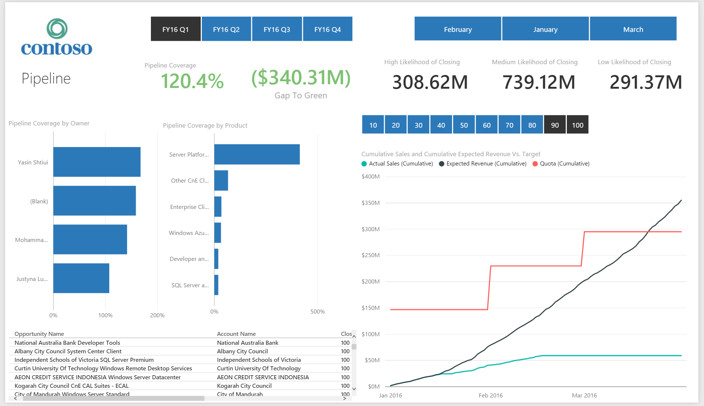

Figure 5: Pipeline View

**Description:** This view focuses on how healthy the pipeline of the business is. The main way pipeline health is evaluated is by measuring pipeline coverage (i.e. if I was to sum up my actual sales with all my open opportunities, how much of my quota would I reach). Some sales mangers like to use percentages higher than 100% (e.g. 120%) to indicate a healthy pipeline as they assume not all opportunities will be closed. In our report, any pipeline coverage above 100% appears as green. On the report pipeline coverage is also split by sales team/salesperson and product to provide a more detailed understanding of pipeline.

In our sample report we can e.g. see that while we have very impressive pipeline coverage for Server Platform (nearly 500%), some of our other products have much lower pipeline coverage. As a Sales Manager I could investigate why certain products are not generating as much interest and reprioritize the focus of my sales teams away from Server Platform to other areas. We have also enabled drilling down capabilities in our owner and product pipeline coverage bar graphs. This means that clicking on a particular sales team will uncover all of the sales people that belong to the team, whereas clicking on a product family will uncover all the products associated with it. For example, ‘drilling’ into Server Platform will allow me to see whether there is one product in particular that has resulted in the huge surge of pipeline coverage for Server Platform, or are all of my Server Platform products extremely popular. As you can see below, it appears to be the latter with all apart from one Server Platform product having very good pipeline coverage:

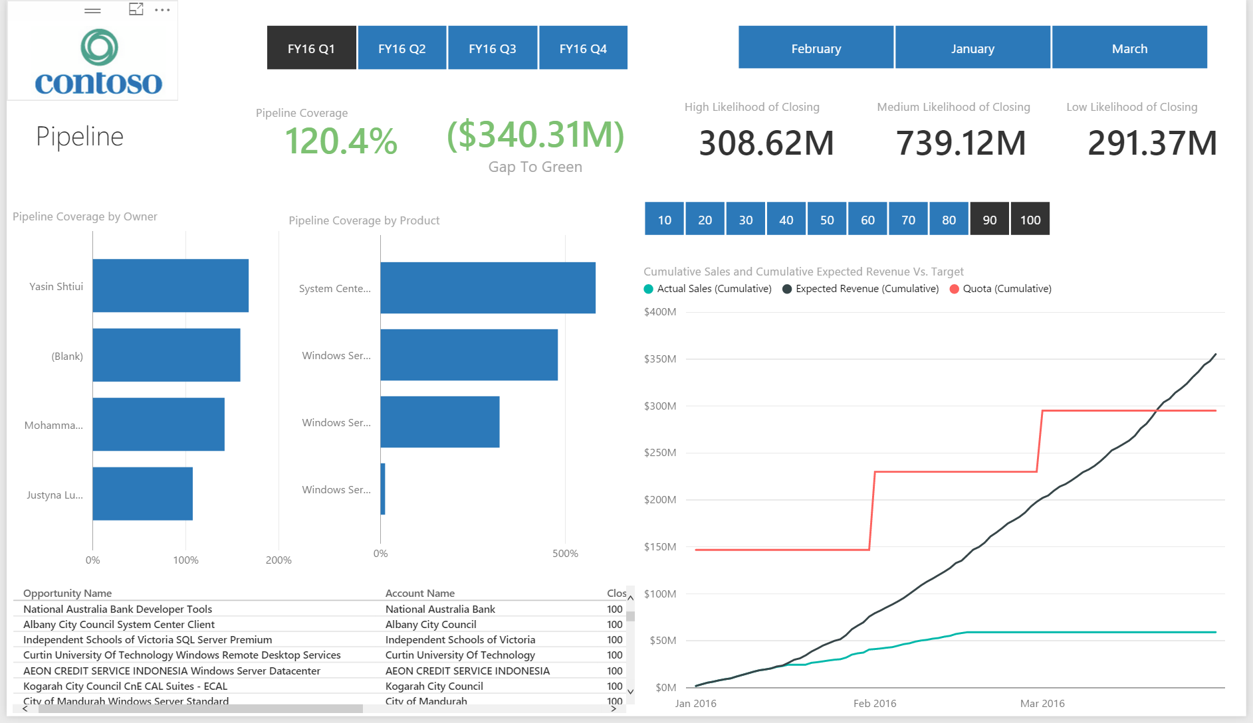

Figure 6: Pipeline View drilling down into Product

Another important metric that complements pipeline coverage is ‘Gap to Green’. Gap to green looks at how much more revenue I need in my pipeline to be able to reach my quota. A negative gap to green (as shown above in green) indicates I’ve already surpassed the amount I need. The other card metrics on the report look at the amount of opportunities that have a high, medium and low likelihood of closing.

The cumulative graph in the bottom right hand corner provides some very important insights on the Pipeline page. The green line shows all of my cumulative actual sales for the chosen time period (dictated by the time slicers at the top of the page). In the example above we show actual sales for FY16Q1. For actual sales we expect an upward trending line which goes flat after our current day (as actual sales cannot be made in the future). My cumulative expected revenue line shows me a sum of actual sales along with my expected revenue based on open opportunity close dates. This line should perfectly overlay my actual sales line (as I cannot have open revenue estimated to close in the past). Finally, I also have a cumulative quota that goes up in monthly increments (here we assume quotas are set on a monthly basis). A very useful question this graph helps answer is ‘at which point in the month/quarter/year can I expect to pass my quota. I can further use my product and owner bar graphs to cross filter my cumulative graph to answer that question about specific people or products.

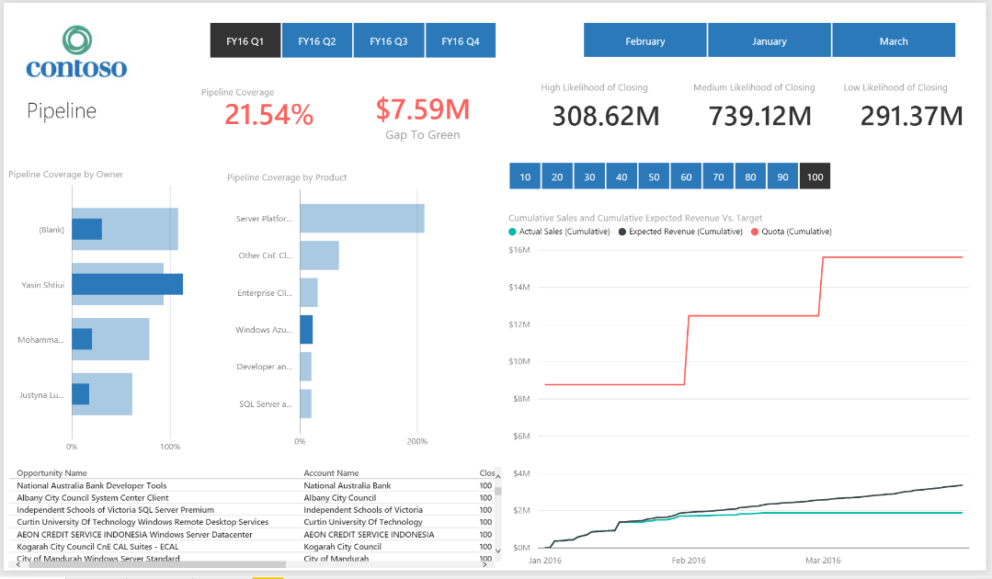Finally, we also have a slicer right above the cumulative graph that depicts the probability with which an opportunity will close. 10% indicates an extremely low probability of closing whereas 100% indicates an extremely high probability of closing. A Sales Manager can thus start with 100% and continue incrementing downwards until they find out which opportunities need to close in order to reach their target. I can also do this for specific products or salespeople. In the example below, I am looking at all opportunities that have 100% close probability for Azure and I can see I now have only a 20% pipeline coverage:

Figure 7: Pipeline View Looking at Azure 100% Close Probability

As I continue selecting Azure opportunities based on their probability of closing, I can see that even if I select everything between 20% to 100% I still do not have full pipeline coverage (short by 0.34%). In order to hit my product quota for Azure I therefore need to close all of my opportunities, even those that are very unliekly to close. Finally, if I ever want more granular detail I can expand out my table visual that gives me infromation about individual opportunities.

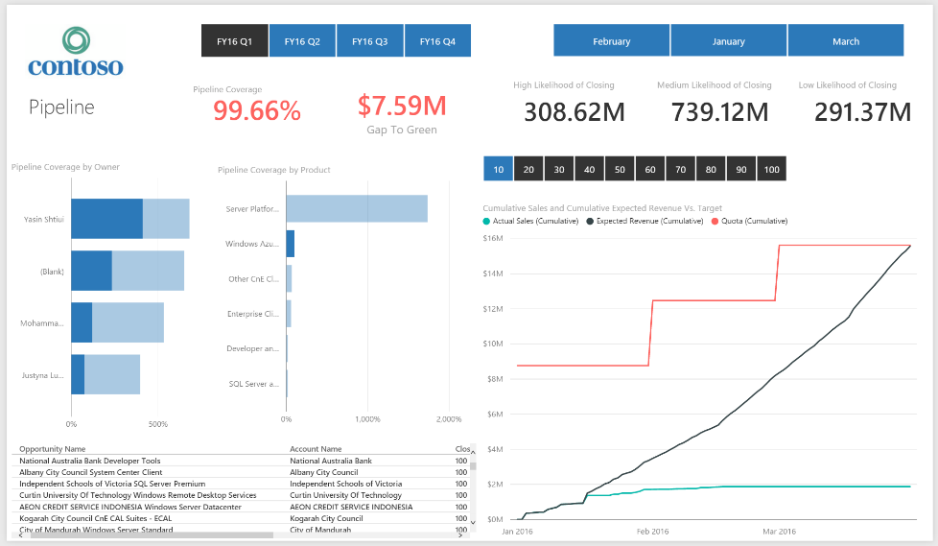

Figure 8: Pipeline View Looking at Azure 20%-100% Close Probability

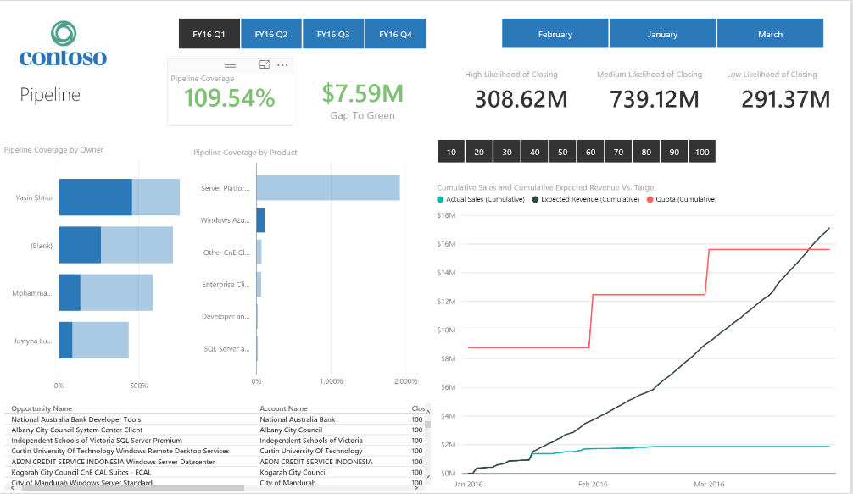

Figure 9: Pipeline View Looking at Azure 10%-100% Close Probability

**Owner View:**

**Aim:** As a Sales Manager, I want to see how my sales teams/sales people are performing compared to each other.

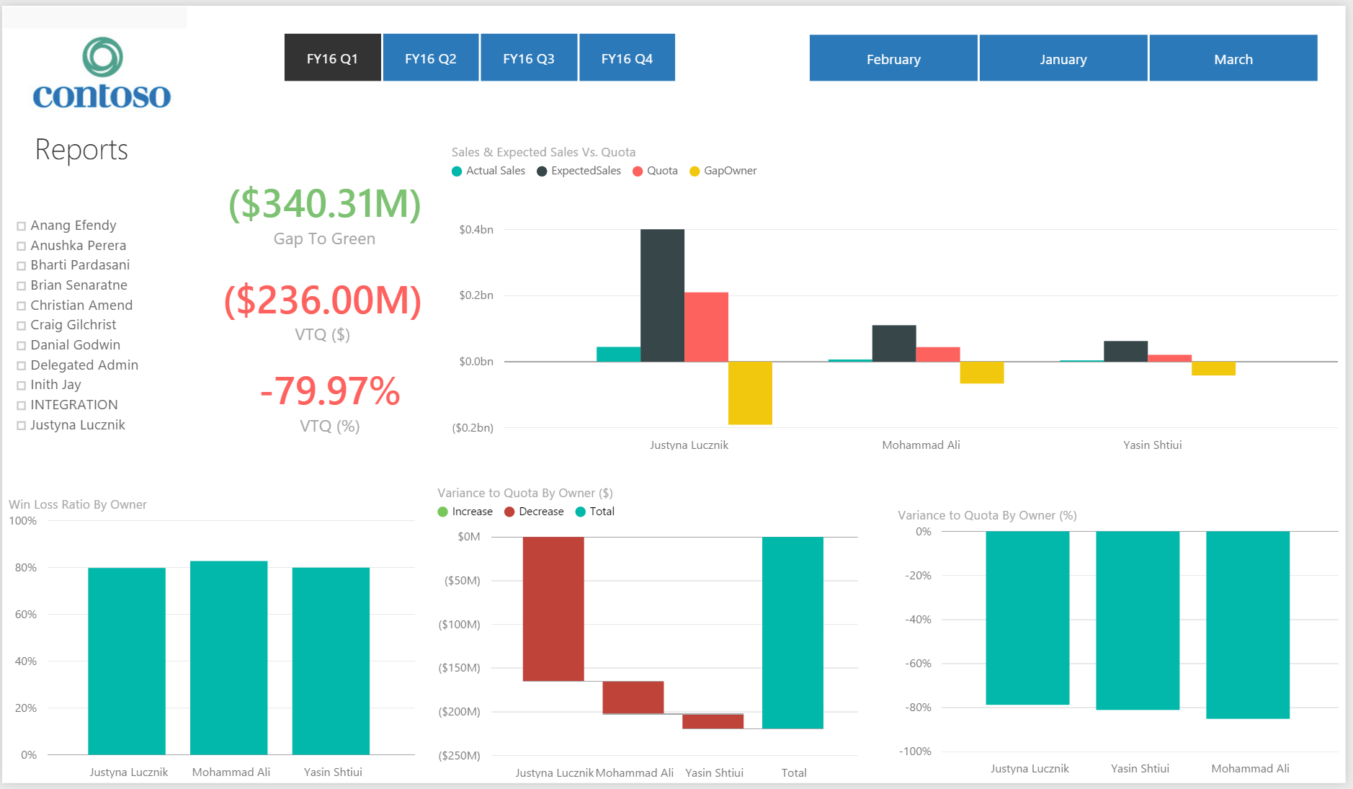

Figure 10: Owner View

**Description:** The Owner View allows Sales Managers to learn more about how their various sales teams are performing. We again have time slicers at the top which our contextual to our fiscal year. We can either drill into a specific quarter or even month. In our report, we are looking at our current quarter.

The top graph brings together the most important information from our disparate data sources. For every sales team, we report the actual closed sales, the expected sales (actual sales + open pipeline), the target and the gap to green. We can compare all our sales teams together as well as drill into specific sales team to see how the individual sales people are doing as well. The example below drills into Justyna’s team:

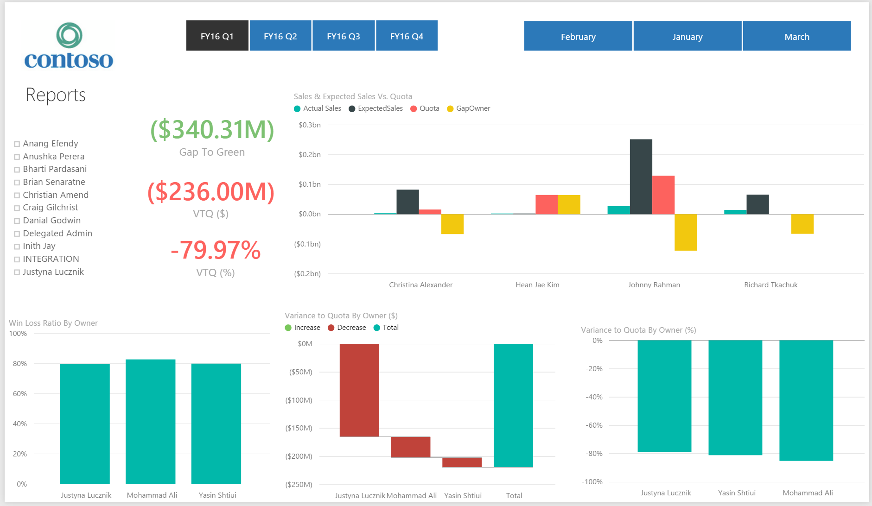

Figure 118: Owner View - drill down into a team

We have our key business metrics on the left hand side. We should be familiar with ‘Gap to Green’ from our Pipeline View (this is our expected revenue – quota). We also report on our ‘Variance to Quota’ both in terms of revenue and percentage. Variance to Quota tells us how much our actual sales are away from our target. Based on the example above we therefore see that whilst our gap to green is positive, our variance to quota is very negative (nearly -80%). As a Sales Manager I can therefore see that whilst my pipeline appears very healthy, I still need to close a lot of opportunities to reach my target.

The bar graphs at the bottom of the page show me a more detailed breakdown of my variance to quota by individual sales team (complemented with the drill down functionality). I can see e.g. that whilst Mohammad has my lowest VTQ from a percentage perspective, Justyna has a significantly lower VTQ from a revenue perspective and she should be the one I focus my attention on.

The final metric I can see is my win loss ratio by opportunity owner. This tells me how many opportunities my sales team(s) won out of all the opportunities they closed, giving me insight into how effective they are at winning deals. Finally, I also have a filter on the left hand side which lets me focus on a select number of sales teams/salespeople. This is particularly useful in cases where a Sales Manager may have lots of direct reports which may overcrowd the screen.

**Product View:**

**Aim:** As a Sales Manager, I want to see how my products are tracking against each other.

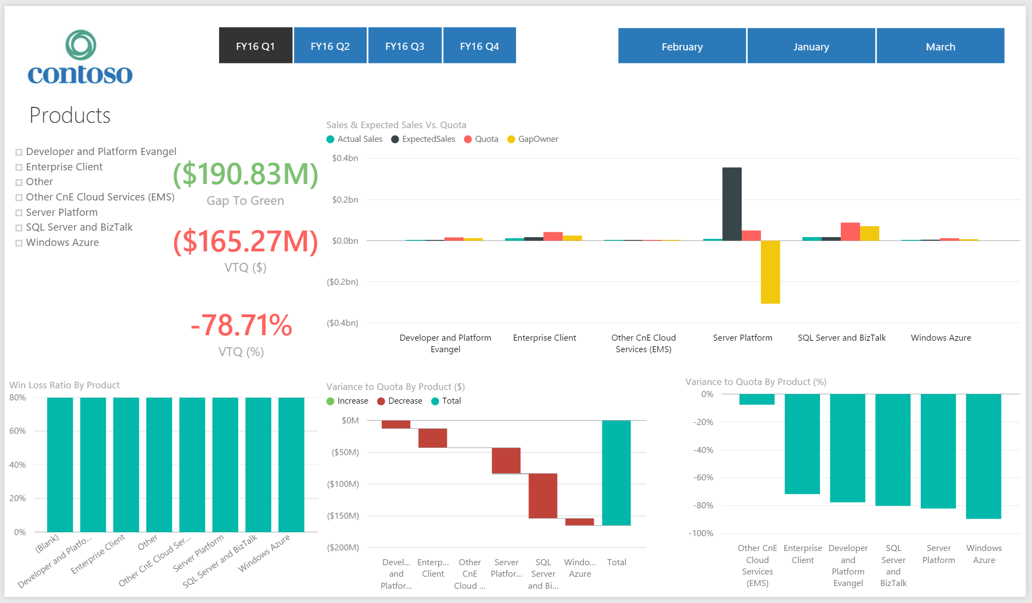

Figure 12: Product View

**Description:** The Product View has a very similar layout to the Owner View. The metrics and graphs presented are the same but for a product centric view instead of an owner one. Looking at the example above, this is a good moment to use the product slicer on the left hand side as we have a lot of product categories that are crowding the screen. We can also use additional filters available in the filter pane on the right hand side to give us even more granular detail. For example, I can use the ‘Owner’ filter to drill into a specific sales team. I can thus look at all of my metrics for a given product (Server Platform in the example below) and a specific sales team or salesperson (Justyna’s team below):

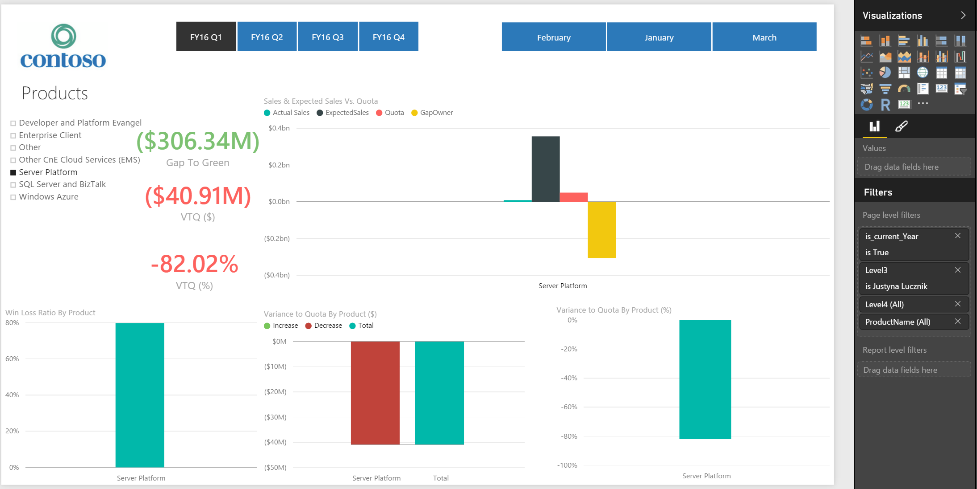

Figure 13: Product View Filtered by Product and Sales Team